**DN 4.0 JAVA FSE SOLUTIONS – WEEK 4**

**SKILL: Spring REST using Spring Boot 3**

**Creating Microservices for account and loan  
Code:**

**Account Microservice**

**src/main/java/com/cognizant/account/controller/AccountController.java**

package com.cognizant.account.controller;

import org.springframework.web.bind.annotation.*;

import java.util.Map;

@RestController

@RequestMapping("/accounts")

public class AccountController {

@GetMapping("/{number}")

public Map<String, Object> getAccount(@PathVariable String number) {

return Map.of(

"number", number,

"type", "savings",

"balance", 234343

);

}}

Output:

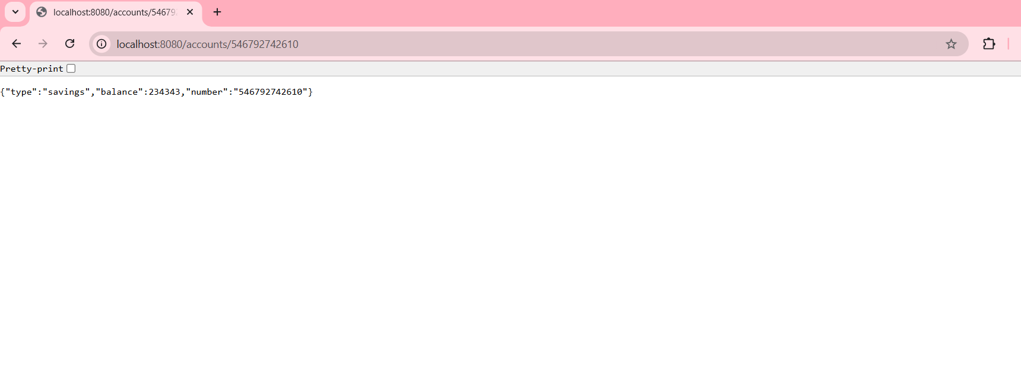

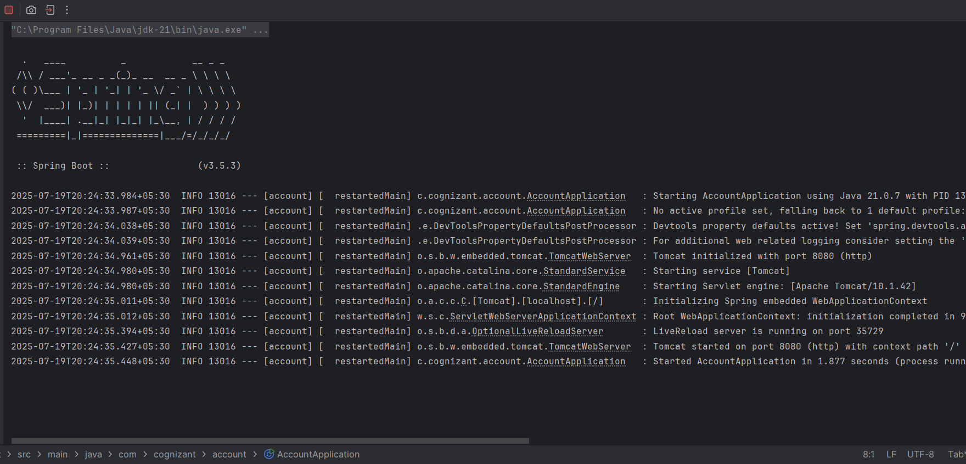

**Loan Microservice**

**Code  
src/main/resources/application.properties**

server.port=8081

**src/main/java/com/cognizant/loan/controller/LoanController.java**

package com.cognizant.loan.controller;

import org.springframework.web.bind.annotation.*;

import java.util.Map;

@RestController

@RequestMapping("/loans")

public class LoanController {

@GetMapping("/{number}")

public Map<String, Object> getLoan(@PathVariable String number) {

return Map.of(

"number", number,

"type", "car",

"loan", 400000,

"emi", 3258,

"tenure", 18

);

}

}

Output  
